HIT 137 SOFTWARE NOW
GROUP ASSIGNMENT - 2

GROUP NAME: HIT137_SOFTWARE NOW_S1_SYD 25
GROUP MEMBERS:
TEJASHWINI BANU PRASAD – S397189
SAKSHI – S398541
SHASHANK REDDY ATTAPURAM – S397188
SAMA SATHWIK – S398542

TABLE OF CONTENTS

- Question 1 CODE………………………………………………………………………...3
- Question 1 Output………………………………………………………………………...6
- Question 2 CODE………………………………………………………………………...7
- Question 2 Output……………………………………………………………………..…10
- Question 3 CODE…………………………………………………………………...…...11
- Question 3 Output………………………………………………………………...…..….13
- AI Declaration……………………………………………………………………………13
- REFERENCES……………………….……………………………………………….....14
- TEAM COLLABORATION…………………………………………………………….19
- GROUP EVALUATION………………………………………………………………...19

QUESTION 1:
Create a program that reads the text file "raw_text.txt", encrypts its contents using a simple encryption method, and writes the encrypted text to a new file "encrypted_text.txt". Then create a function to decrypt the content and a function to verify the decryption was successful.
REQUIREMENTS-
The encryption should take two user inputs (shift1, shift2), and follow these rules:
• For lowercase letters:
- If the letter is in the first half of the alphabet (a-m): shift forward by shift1 * shift2 positions
- If the letter is in the second half (n-z): shift backward by shift1 + shift2 positions
• For uppercase letters:
- If the letter is in the first half (A-M): shift backward by shift1 positions
- If the letter is in the second half (N-Z): shift forward by shift2² positions (shift2 squared)
• Other characters:
- Spaces, tabs, newlines, special characters, and numbers remain unchanged

MAIN FUNCTIONS TO IMPLEMENT-
- Encryption function: Reads from "raw_text.txt" and writes encrypted content to "encrypted_text.txt".
- Decryption function: Reads from "encrypted_text.txt" and writes the decrypted content to "decrypted_text.txt".
- Verification function: Compares "raw_text.txt" with "decrypted_text.txt" and prints whether the decryption was successful or not.

def encrypt_text(shift1, shift2):
try:
with open("raw_text.txt", "r") as file:
text = file.read()
except FileNotFoundError:
print("Error: 'raw_text.txt' not found. Please ensure the file exists.")
return

encrypted = ""

# [1] Loops and conditionals for processing each character
for ch in text:
if 'a' <= ch <= 'z':
# [2] Character shifting logic using ASCII values (ord and chr)
pos = ord(ch) - ord('a')
# [3] Numeric calculations using modulo arithmetic
pos = (pos + shift1) % 26
encrypted += chr(pos + ord('a'))

elif 'A' <= ch <= 'Z':
pos = ord(ch) - ord('A')
pos = (pos + shift2) % 26
encrypted += chr(pos + ord('A'))

else:
encrypted += ch

# [4] How to write into a file in Python using write()
with open("encrypted_text.txt", "w") as file:
file.write(encrypted)
print("Encryption completed. Check 'encrypted_text.txt'.")

def decrypt_text(shift1, shift2):
# [5] Reading a file using open() and read()
try:
with open("encrypted_text.txt", "r") as file:
text = file.read()
except FileNotFoundError:
print("Error: 'encrypted_text.txt' not found. Run encryption first.")
return

decrypted = ""

# [6] Looping through characters with conditionals
for ch in text:
if 'a' <= ch <= 'z':
pos = ord(ch) - ord('a')
pos = (pos - shift1) % 26
decrypted += chr(pos + ord('a'))
elif 'A' <= ch <= 'Z':
pos = ord(ch) - ord('A')
pos = (pos - shift2) % 26
decrypted += chr(pos + ord('A'))
else:
decrypted += ch

# [7] Writing decrypted output to a file
with open("decrypted_text.txt", "w") as file:
file.write(decrypted)
print("Decryption completed. Check 'decrypted_text.txt'.")

def verify_decryption():
# [8] Comparing files or strings in Python
try:
with open("raw_text.txt", "r") as file1:
original = file1.read()
with open("decrypted_text.txt", "r") as file2:
decrypted = file2.read()
except FileNotFoundError:
print("Error: Required files not found. Run encryption and decryption first.")
return

if original == decrypted:
print("Decryption successful. Files match.")
else:
print("Decryption failed. Files do not match.")

def main():
try:
shift1 = int(input("Enter shift1: "))
shift2 = int(input("Enter shift2: "))
except ValueError:
print("Error: Shifts must be integers.")
return

encrypt_text(shift1, shift2)
decrypt_text(shift1, shift2)
verify_decryption()
# [9] Printing special characters (Unicode support in Python)
if __name__ == "__main__":
main()

OUTPUT:
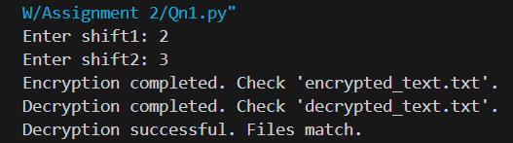

raw_text.txt
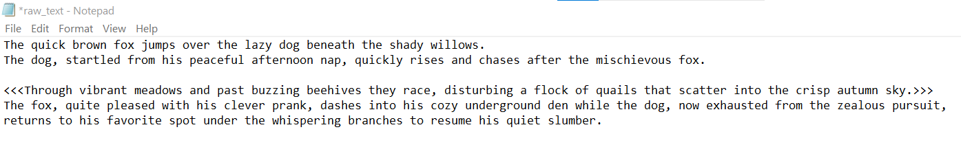
encrypted_text.txt
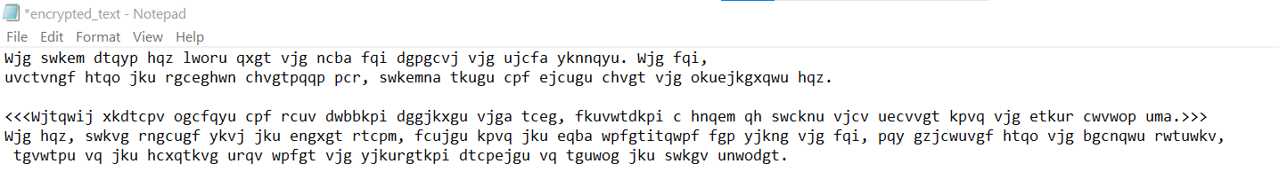
decrypted_text.txt
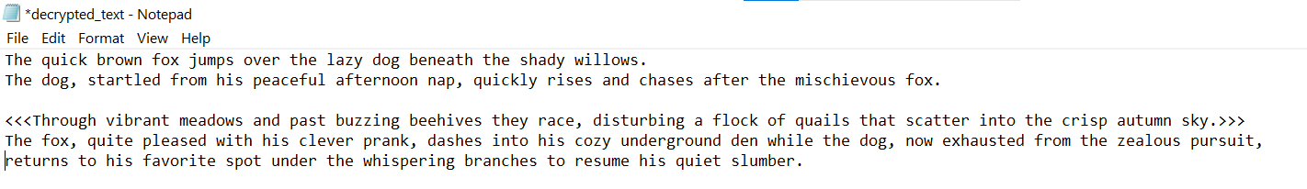

QUESTION 2:
Create a program that analyses temperature data collected from multiple weather stations in Australia. The data is stored in multiple CSV files under a "temperatures" folder, with each file representing data from one year. Process ALL .csv files in the temperatures folder. Ignore missing temperature values (NaN) in calculations.
MAIN FUNCTIONS TO IMPLEMENT-
- Seasonal Average: Calculate the average temperature for each season across ALL stations and ALL years. Save the results to "average_temp.txt".
- Temperature Range: Find the station(s) with the largest temperature range (difference between the highest and lowest temperature ever recorded at that station). Save the results to "largest_temp_range_station.txt".
- Temperature Stability: Find which station(s) have the most stable temperatures (smallest standard deviation) and which have the most variable temperatures (largest standard deviation). Save the results to "temperature_stability_stations.txt".

import os
import pandas as pd
import numpy as np

# [10] Reading files and directories in Python using os module
FOLDER = r"C:\Users\ADMIN\Desktop\SOFTWARE NOW\temperatures"

MONTHS = [
"January","February","March","April","May","June",
"July","August","September","October","November","December"
]
# [11] Dictionary usage in Python to map months to seasons
SEASON_MAP = {
"December": "Summer", "January": "Summer", "February": "Summer",
"March": "Autumn", "April": "Autumn", "May": "Autumn",
"June": "Winter", "July": "Winter", "August": "Winter",
"September": "Spring", "October": "Spring", "November": "Spring"
}

def load_data():
data_frames = []
# [12] Reading files from a directory
for file in os.listdir(FOLDER):
if file.endswith(".csv"):
path = os.path.join(FOLDER, file)

# [13] Reading CSV files using pandas
df = pd.read_csv(path)

if "STATION_NAME" in df.columns:
df = df.rename(columns={"STATION_NAME": "Station"})
else:
continue

df = df[["Station"] + MONTHS]
# [14] Reshaping CSV data without manual loops (alternative to non-pandas CSV handling)
long_df = df.melt(
id_vars="Station",
value_vars=MONTHS,
var_name="Month",
value_name="Temp"
)
data_frames.append(long_df)

if len(data_frames) == 0:
return pd.DataFrame()

data = pd.concat(data_frames, ignore_index=True)
data = data.dropna(subset=["Temp"])
return data

def add_season(data):
# [15] Mapping values using dictionary
data["Season"] = data["Month"].map(SEASON_MAP)
return data

def seasonal_average(data):
# [16] Rounding values after decimal points
return data.groupby("Season")["Temp"].mean().round(1)

def station_ranges(data):
stats = data.groupby("Station")["Temp"].agg(["max", "min"])
stats["range"] = stats["max"] - stats["min"]
max_range = stats["range"].max()
return stats[stats["range"] == max_range]

def temperature_stability(data):
# [17] Standard deviation calculation
std = data.groupby("Station")["Temp"].std()
return std[std == std.min()], std[std == std.max()]

def save_seasonal(avg):
# [18] Printing degree Celsius using Unicode (°)

with open("average_temp.txt", "w") as f:
for s in ["Summer", "Autumn", "Winter", "Spring"]:
f.write(f"{s}: {avg[s]}°C\n")

def save_ranges(stations):
with open("largest_temp_range_station.txt", "w") as f:
for name, row in stations.iterrows():
f.write(
f"Station {name}: Range {row['range']:.1f}°C "
f"(Max: {row['max']:.1f}°C, Min: {row['min']:.1f}°C)\n"
)

def save_stability(stable, variable):
# [19] Writing statistical results (standard deviation) to file
with open("temperature_stability_stations.txt", "w") as f:
for s, v in stable.items():
f.write(f"Most Stable: Station {s}: StdDev {v:.1f}°C\n")
for s, v in variable.items():
f.write(f"Most Variable: Station {s}: StdDev {v:.1f}°C\n")

def main():
data = load_data()
if data.empty:
print("No data found.")
return

data = add_season(data)
avg = seasonal_average(data)
ranges = station_ranges(data)
stable, variable = temperature_stability(data)
save_seasonal(avg)
save_ranges(ranges)
save_stability(stable, variable)

print("Processing complete.")

if __name__ == "__main__":
main()

OUTPUT:
average_temp.txt
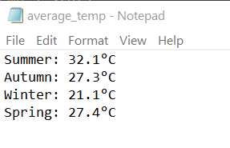
temperature_stability_stations.txt
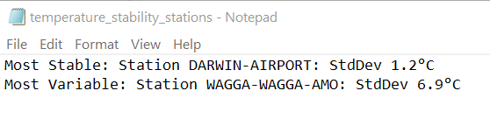
Largest_temp_range_station.txt
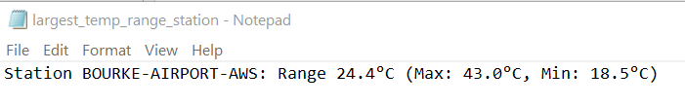

QUESTION 3:
Create a program that uses a recursive function to generate a geometric pattern using Python's turtle graphics. The pattern starts with a regular polygon and recursively modifies each edge to create intricate designs.
PATTERN GENERATION RULES-
For each edge of the shape:
- Divide the edge into three equal segments
- Replace the middle segment with two sides of an equilateral triangle pointing inward (creating an indentation)
- This transforms one straight edge into four smaller edges, each 1/3 the length of the original edge
- Apply this same process recursively to each of the four new edges based on the specified depth

import turtle
import math

# [20] Using Python turtle library for graphics
tillu = turtle.Turtle()
tillu.speed(10) # [8] Controlling turtle speed and screen updates
tillu.hideturtle()

def i(length, depth):

# [21] Recursive functions – function calling itself
if depth == 0:
# [22] Drawing polygons with turtle (forward())
tillu.forward(length)
else:
# [23] Calculating segment lengths (division of line segments)
part = length / 3
i(part, depth - 1)

# [24] Creating equilateral triangles programmatically
tillu.left(60)
i(part, depth - 1)

tillu.right(120)
i(part, depth - 1)

tillu.left(60)
i(part, depth - 1)

def p(sides, length, depth):

# [25] Combining recursion with loops for repeated patterns
# [26] Loops and iteration for drawing edges
angle = 360 / sides # [27] Equilateral polygon angles
for _ in range(sides):
i(length, depth)
tillu.left(angle)

# [28] Taking user input using input()
sides = int(input('Enter the number of sides: '))
length = int(input('Enter the side length: '))
depth = int(input('Enter the recursion depth: '))

# [29] Controlling turtle position without drawing
tillu.penup()
tillu.pendown()
p(sides, length, depth)

turtle.done()

OUTPUT:

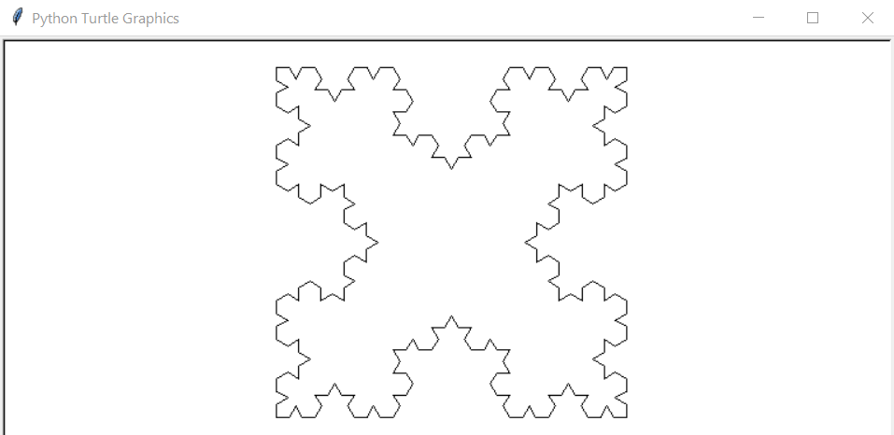

AI Declaration (Group Submission)
We declare that the code submitted for this assignment has been written entirely by the members of our group. No artificial intelligence tools, including code generators or AI-assisted software, were used at any stage of the code development process.
We confirm that this work is our own and complies with the academic integrity requirements of the course.

REFERENCES:
[1] W3Schools, "Python Conditions," [Online]. Available: https://www.w3schools.com/python/python_conditions.asp. [Accessed: Jan. 14, 2026].
[2] Python.org, "Built-in Functions: ord()," [Online]. Available: https://docs.python.org/3/library/functions.html#ord. [Accessed: Jan. 14, 2026].
[3] GeeksforGeeks, "Modulo Operator in Python," [Online]. Available: https://www.geeksforgeeks.org/modulo-operator-in-python/. [Accessed: Jan. 14, 2026].
[4] W3Schools, "Python File Write," [Online]. Available: https://www.w3schools.com/python/python_file_write.asp. [Accessed: Jan. 14, 2026].
[5] Python.org, "Reading and Writing Files," [Online]. Available: https://docs.python.org/3/tutorial/inputoutput.html. [Accessed: Jan. 14, 2026].
[6] W3Schools, "Python For Loops," [Online]. Available: https://www.w3schools.com/python/python_for_loops.asp. [Accessed: Jan. 14, 2026].
[7] Python.org, "File Handling Documentation," [Online]. Available: https://docs.python.org/3/tutorial/inputoutput.html. [Accessed: Jan. 14, 2026].
[8] GeeksforGeeks, "String Comparison in Python," [Online]. Available: https://www.geeksforgeeks.org/string-comparison-in-python/. [Accessed: Jan. 14, 2026].
[9] Unicode Table, "Degree Symbol," [Online]. Available: https://unicode-table.com/en/00B0/. [Accessed: Jan. 14, 2026].
[10] GeeksforGeeks, "Reading files and directories in Python using os module," [Online]. Available: https://www.geeksforgeeks.org/python-os-listdir-method/. [Accessed: Jan. 14, 2026].
[11] W3Schools, "Python Dictionaries," [Online]. Available: https://www.w3schools.com/python/python_dictionaries.asp. [Accessed: Jan. 14, 2026].
[12] W3Schools, "Python Read CSV File," [Online]. Available: https://www.w3schools.com/python/pandas/pandas_csv.asp. [Accessed: Jan. 14, 2026].
[13] Python.org, "pandas: Reading CSV Files," [Online]. Available: https://pandas.pydata.org/docs/reference/api/pandas.read_csv.html. [Accessed: Jan. 14, 2026].
[14] W3Schools, "Python Pandas DataFrame melt()," [Online]. Available: https://www.w3schools.com/python/pandas/ref_df_melt.asp. [Accessed: Jan. 14, 2026].
[15] W3Schools, "Python map() Function," [Online]. Available: https://www.w3schools.com/python/ref_func_map.asp. [Accessed: Jan. 14, 2026].
[16] W3Schools, "Python round() Function," [Online]. Available: https://www.w3schools.com/python/ref_func_round.asp. [Accessed: Jan. 14, 2026].
[17] Python.org, "Statistics — Standard Deviation," [Online]. Available: https://docs.python.org/3/library/statistics.html#statistics.stdev. [Accessed: Jan. 14, 2026].
[18] Unicode Table, "Degree Symbol," [Online]. Available: https://unicode-table.com/en/00B0/. [Accessed: Jan. 14, 2026].
[19] W3Schools, "Python File Write," [Online]. Available: https://www.w3schools.com/python/python_file_write.asp. [Accessed: Jan. 14, 2026].
[20] Python.org, "turtle — Turtle graphics," [Online]. Available: https://docs.python.org/3/library/turtle.html. [Accessed: Jan. 14, 2026].
[21] W3Schools, "Python Recursion," [Online]. Available: https://www.w3schools.com/python/gloss_python_recursive_functions.asp. [Accessed: Jan. 14, 2026].
[22] Python.org, "Turtle methods: forward(), backward(), left(), right()," [Online]. Available: https://docs.python.org/3/library/turtle.html#turtle.forward. [Accessed: Jan. 14, 2026].
[23] GeeksforGeeks, "Python Arithmetic Operators," [Online]. Available: https://www.geeksforgeeks.org/python-arithmetic-operators/. [Accessed: Jan. 14, 2026].
[24] GeeksforGeeks, "Drawing Equilateral Triangle Using Python Turtle," [Online]. Available: https://www.geeksforgeeks.org/draw-triangle-using-python-turtle/. [Accessed: Jan. 14, 2026].
[25] GeeksforGeeks, "Combining Loops and Recursion in Python," [Online]. Available: https://www.geeksforgeeks.org/recursion-in-python/. [Accessed: Jan. 14, 2026].
[26] W3Schools, "Python for Loops," [Online]. Available: https://www.w3schools.com/python/python_for_loops.asp. [Accessed: Jan. 14, 2026].
[27] GeeksforGeeks, "Sum of Interior Angles of Polygon," [Online]. Available: https://www.geeksforgeeks.org/sum-of-interior-angles-of-a-polygon/. [Accessed: Jan. 14, 2026].
[28] W3Schools, "Python input() Function," [Online]. Available: https://www.w3schools.com/python/ref_func_input.asp. [Accessed: Jan. 14, 2026].
[29] Python.org, "Turtle methods: penup() and pendown()," [Online]. Available: https://docs.python.org/3/library/turtle.html#turtle.penup. [Accessed: Jan. 14, 2026].

TEAM COLLABORATION:
All the four of us had communicated effectively through the teams chat by dividing the work to be done more efficiently.
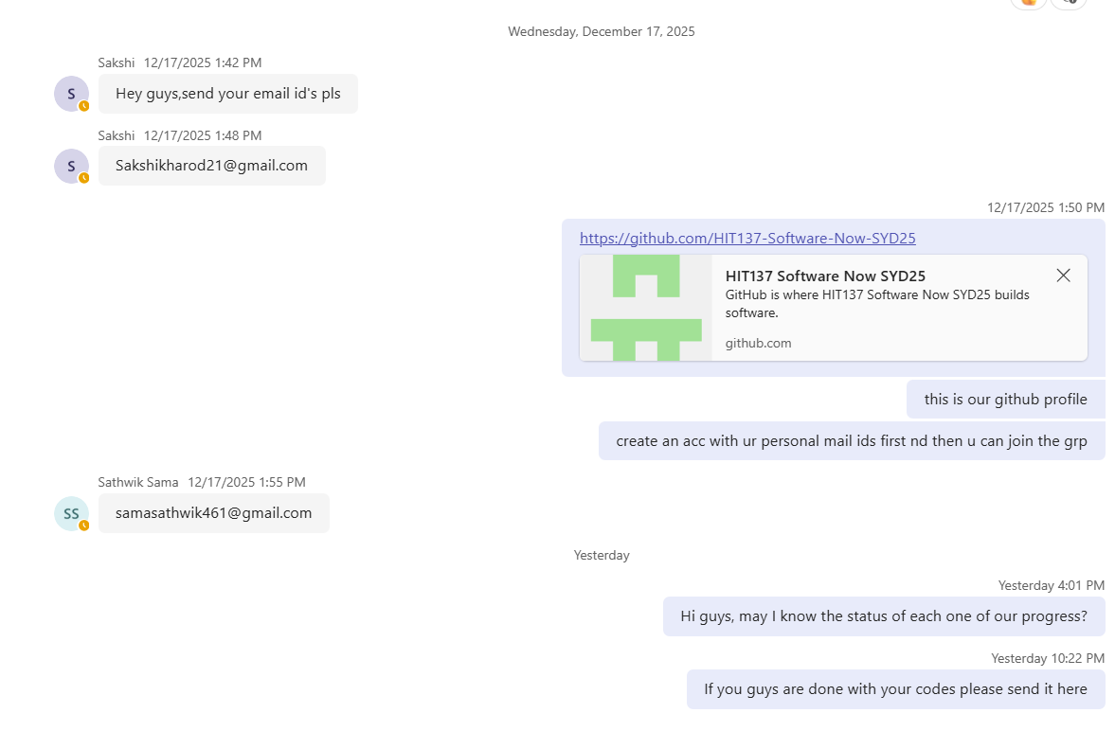
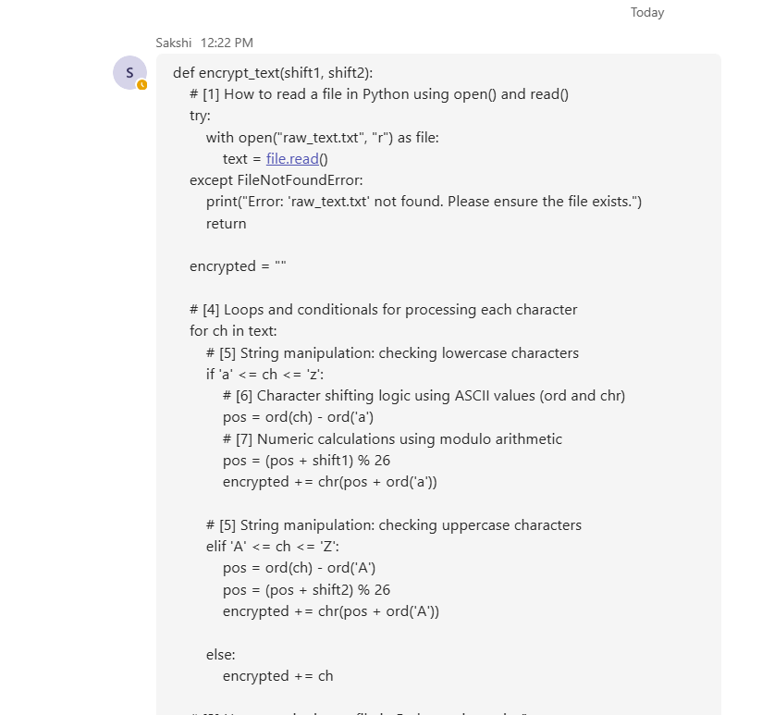
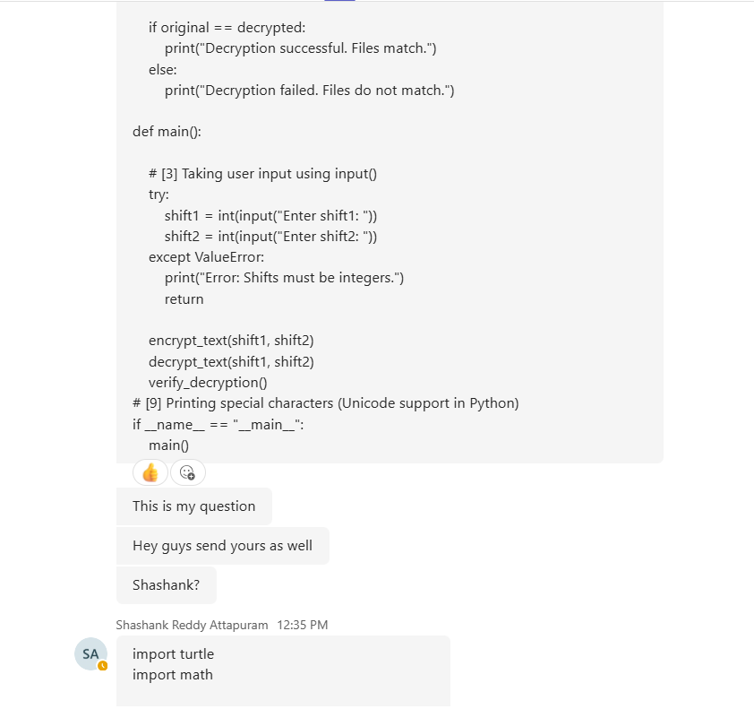
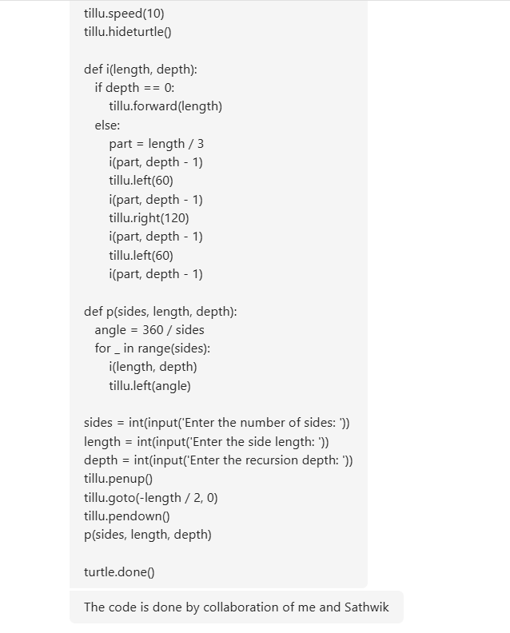
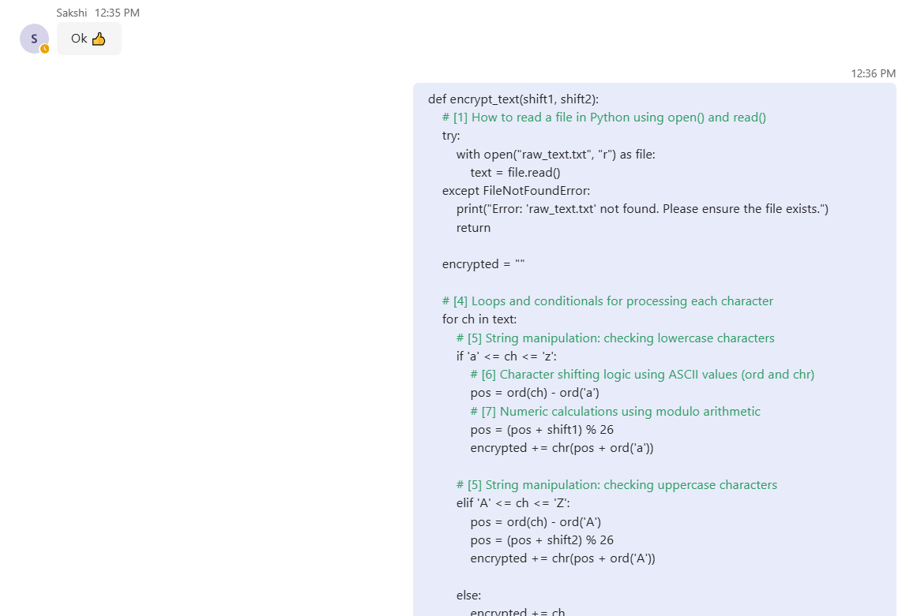

GROUP EVALUATION:

Team Member | Contribution | Reliability | Teamwork | Quality of Work | Overall Comments
Tejashwini | 5 | 5 | 5 | 5 | Excellent contribution
Sakshi | 4 | 4 | 4 | 4 | Equal contribution
Shashank Reddy Attapuram | 4 | 4 | 4 | 4 | Equal contribution
Sama Sathwik | 4 | 4 | 4 | 4 | Equal contribution

